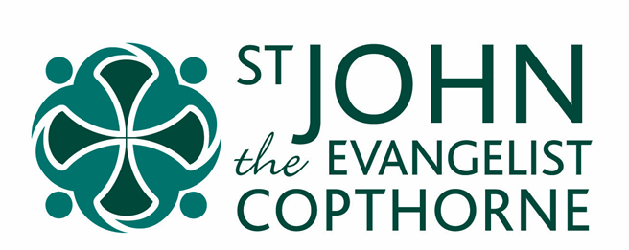

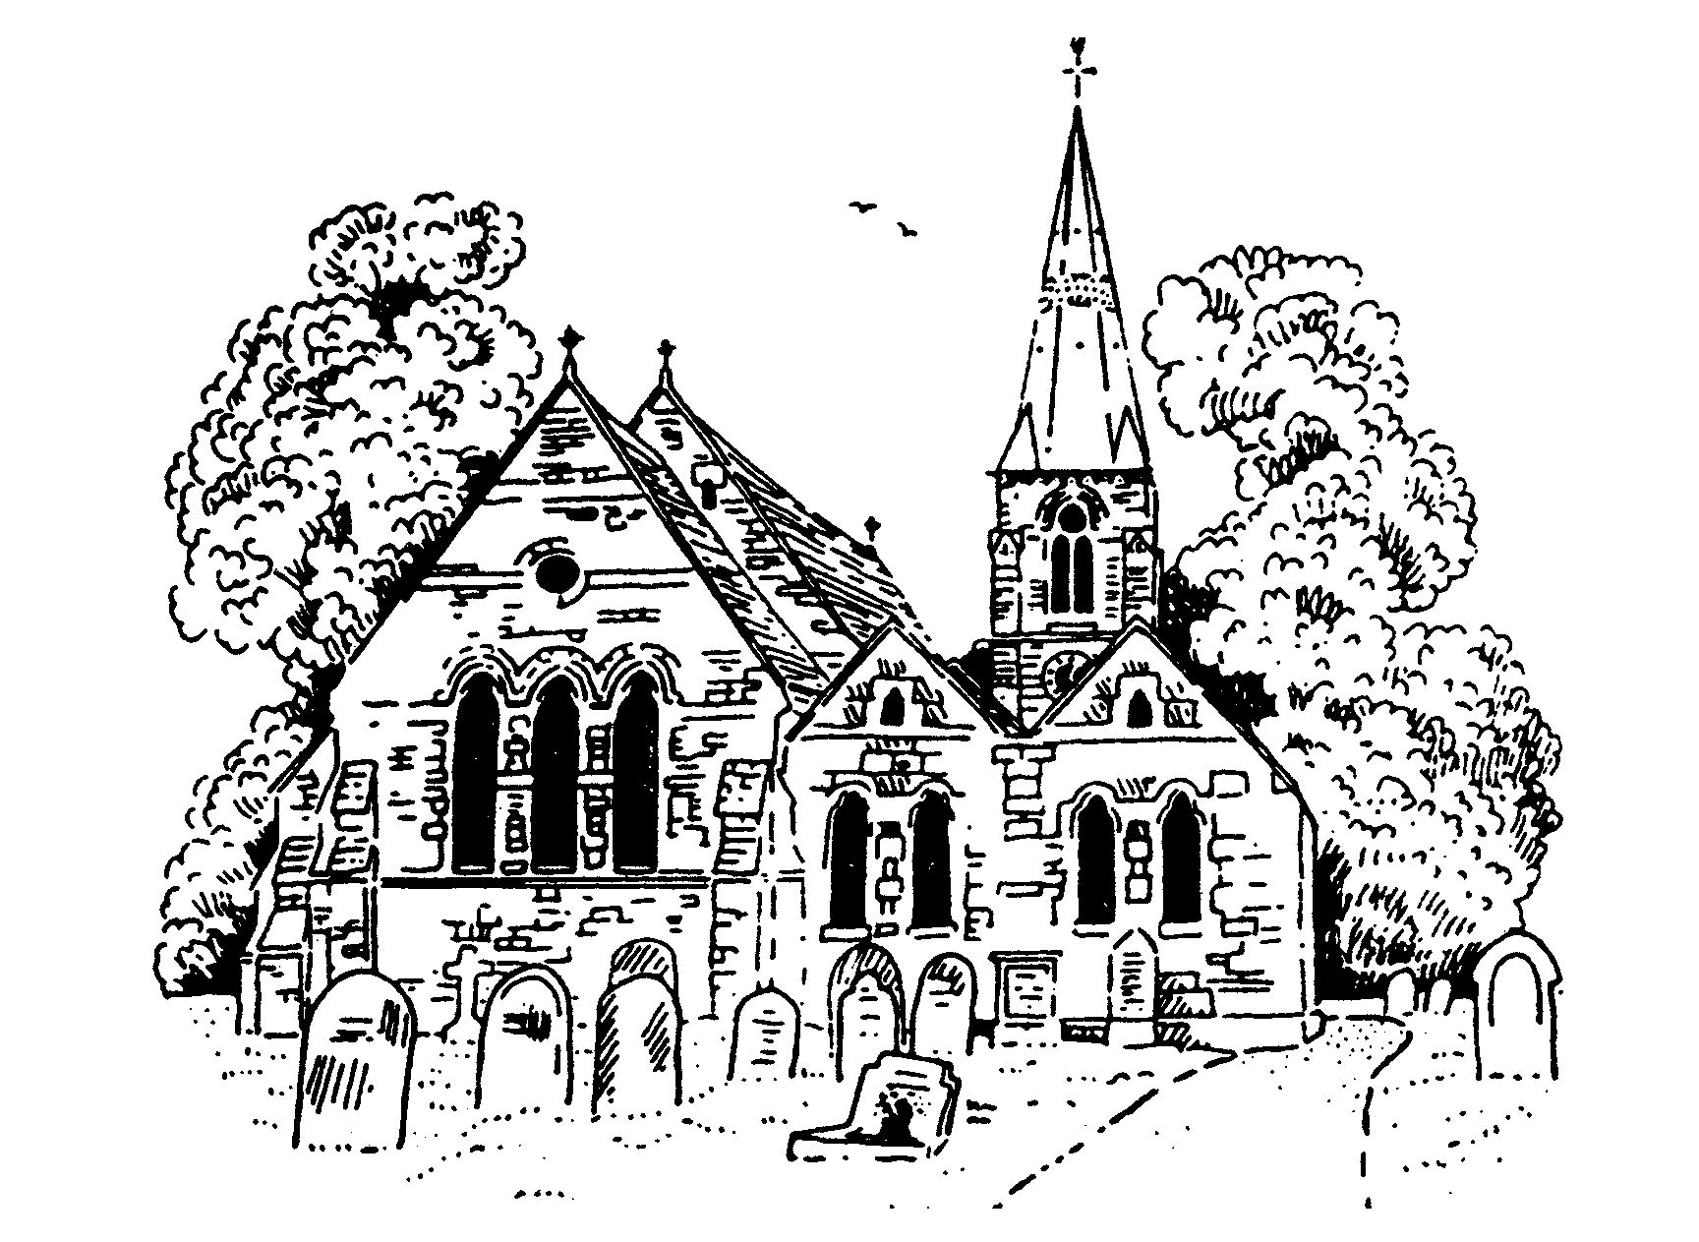

Initial Wedding Information Pack


Getting Married at St John’s Church, Copthorne
“God is love, and those who live in love live in God;
and God lives in them.”
1 John 4:16

Introduction
We are delighted that you are considering making your marriage vows in the sight and presence of God at the church of St John The Evangelist, Copthorne.
Your wedding in church speaks to you of God’s love. His love and faithfulness are gifts to be received from him, and we hope that your wedding day and preparation for it will be a source of joy and blessing to you both, and draw you towards the love of God in Christ Jesus.
This wedding information pack has been designed to help you make all the necessary preparations for the service and to answer some of the questions which you may have about the wedding itself.
Preliminaries
The first step is to arrange a date and time. This is done by meeting with our Weddings Co-ordinator, who will take down all the necessary details. We will first need to be satisfied that you are both British, EEA (European Economic Area) citizens or Swiss nationals or have ‘settled status’. If not, we will refer you to a Designated Register Office (see below).
We will also ask you for a photocopy of your passports (and ask to see the original) and a recent copy of a utility bill with your current address on it and we will help you fill in (if appropriate) the Application for Banns form.
If either or both of you have been widowed we will ask to see the death certificate.
If you have been Divorced

If one or both of you has been married before then it may still be possible for you to marry in our church. However a member of the clergy will meet with you to talk through the implications of your previous marriage, and explain the options open to you, before booking the wedding. They will need to see a copy of your decree absolute. We work within the guidance provided by our bishops and church law.

Banns of Marriage
Before we can conduct your wedding we are required by church law to “read your banns” in church to discover if there are any ‘legal impediments’ to the marriage. On three consecutive Sundays in church the person leading the service will ask if anyone knows of any reason why you cannot be married. This is an ancient practice which is required by church law. Ideally you should be present to hear your banns called on at least one occasion. Depending on your circumstances you may need to have banns called at another church in addition to St John’s Church (see below)
In a few cases banns are inappropriate, and you will need a marriage licence from a surrogate (a priest with the bishop’s authority to issue common licences) or a Superintendent Registrar Certificate.
The Legalities….
There are a number of legal formalities to sort out and we will do our best to help you through these. Please note that government regulations changed with regard to weddings in July 2021.

You can get married in our church if you live in the parish, or if have a ‘qualifying connection’ with the church. These are legal requirements that we must meet to ensure that your marriage is valid. If you do not currently have a ‘qualifying connection’ then it is possible to meet this legal requirement simply by coming to one of our services at least once a month for at least six months.

The clergy who will take your wedding service will want to get to know you a little over the coming months. If you are able to attend Sunday services this will make you feel more at home in the building, and more familiar with those who will be involved in your special service.

Qualifying connections with our parish are:-
If one of you:
- was baptised in our parish; or
- had your confirmation entered in a church register book of our parish; or
- has at any time had your usual place of residence in the parish for at least six months; or
- has at any time habitually attended public worship in our the parish for at least six months;
OR
- a parent of yours has at any time during their lifetime had his or her usual place of residence in the parish for at least six months; or habitually attended public worship in the parish for at least six months;
OR
- one of your parents or grandparents was married in the parish.
The responsibility for establishing a qualifying connection (providing the ‘proof’) is with you. The Church of England website includes forms which can help you to organise the application and evidence for establishing a qualifying connection.
Without these preliminaries, your wedding at St. John’s might not be able to take place, or be legally valid.
Here is the procedure:
a) If both of you live in our parish… your banns will be read at the main Sunday service at Copthorne on three Sundays at some time in the three months before the date of your wedding. There is no separate charge for this procedure, as the statutory fee is included in the cost of your wedding. Though you are not required to do so, you are encouraged to come to church, not just to hear your banns read, but also to share in our worship of God.
b) If one of you lives in another parish in England, in Wales or in Northern Ireland… we will read your banns of marriage at Copthorne on the Sundays indicated in the previous paragraph, but you will also need to arrange for your banns to be called in the other parish of residence during the three months before your wedding. Please note that even if you are on St. John’s Electoral Roll, if one of you lives outside Copthorne parish, you will still need banns read in the other parish.
c) If neither of you live in Copthorne parish, but you do both live in England, Wales or Northern Ireland, and you have a ‘qualifying connection’… you will both need to arrange for your banns to be called in any other parish/es of residence during the three months before your wedding, notifying the other parish about the qualifying connection to Copthorne. #

d) If neither of you live in Copthorne parish, nor do you have a ‘qualifying connection’ but you still want to be married here… you may still be married here by making St. John’s your regular place of worship, and getting on our parish Electoral Roll. (This is different from a civic electoral roll for voting in General Elections etc, and is more like a formal church members list.)
If that applies to you, you need to have been attending St. John’s over at least a six-month period, at a frequency of at least once a month, before you can sign the Electoral Roll application form, which is available at the back of church. You cannot have banns read until you are on the Electoral Roll, and without banns you cannot be married here. You will also need to arrange for your banns to be called in any other parish of residence during the three months before your wedding. Please note that even if you are on St. John’s Electoral Roll, you will still need banns read in the other parish/es.
When the banns have been read there, the parish priest will issue a Banns Certificate for which they will make a charge (see Fees list). You must give this certificate to the priest who is to conduct your wedding at Copthorne: failure to produce this Banns Certificate will prevent your wedding from taking place, so please make sure that you make the appropriate arrangements in good time. If you have any queries about this procedure, we will be happy to discuss them with you in more detail.
Please note that it is entirely the responsibility of the couple getting married to ensure that arrangements are made for the banns to be read in the appropriate places, and to pass the certificate on to the officiating priest. A simple way of checking this is by asking which dates the banns are to be read in the church/es; - it is nice to be there to hear them read in any case.
e) If you both hold a British passport but one of you lives in Scotland, Northern Island or Isle of Man, or is domiciled abroad, … banns cannot be used in these circumstances. You will need to arrange a Common Licence for your wedding. Provided that one of you has a qualifying connection with St John’s, a Common Licence can be obtained through a surrogate (see above).
There is a supplementary fee, (please see fees lists) payable to the surrogate for this licence, and you will need to make an application to them three months before the date of your wedding.
f) Marriage of non-British/Irish Nationals
Only the following persons can be married by Banns or Common Licence:
- British or Irish citizens
- Nationals from the following countries who have obtained settled or pre settled status:
Austria, Belgium, Bulgaria, Croatia, Republic of Cyprus, Czech Republic, Demark, Estonia, Finland, France, Germany, Greece, Hungary, Iceland, Italy, Latvia, Liechtenstein, Luxembourg, Malta, Netherlands, Norway, Poland, Portugal, Romania, Slovakia, Slovenia, Spain, Sweden, Switzerland.
- Nationals from other counties, who have obtained settled status (due to having a family member with nationality from an European Economic Area country.)
A person who does not fall into one of these categories must apply for a Superintendent Registrar’s Certificate (civil preliminaries). You must attend together at a Designated Register Office, the nearest to Copthorne being West Sussex (Crawley), Crawley Library, Southgate Avenue, RH10 6HG. If one or other of you has a qualifying connection with St John’s, a Superintendent Registrar’s Certificate can be granted to authorise the marriage to take place here.
The certificate issued needs to be shown to the priest taking the marriage. The schedule document will be checked and this is the document which will be signed after the marriage vows have been taken.
If you have settled status or pre settled status you will be asked to use the online EUSS status checker tool to request a code which will enable us to check your status before booking your wedding.
Marriage Certificates
Since July 2021, Churches no longer provide marriage certificates. Instead these need to be obtained from a Designated Register Office, the nearest to Copthorne being West Sussex (Crawley), Crawley Library, Southgate Avenue, RH10 6HG. You will sign a marriage document or schedule on your wedding day which will also be signed by the officiating member of clergy. It will be your responsibility to take this to the register office within 7 days. You can ask someone else to take or send it for you but it is your responsibility to ensure it is received. You will then be able to access your certificate online on payment of a fee to the Registrar.
Post-Dated Passports
If you are going abroad for your honeymoon, you may like to have passports issued in advance which bear your married names. It is not compulsory; it is fine for you to travel on your existing passports. If you wish to take advantage of this facility, you will need an application form for “Post-Dated Passports” from the Post Office.
Once the form is completed, you should then ask the priest who is to marry you to countersign it before you send it off. We advise you to apply for passports at least three months before your wedding, as they take time to be issued. Naturally, post-dated passports cannot be used until after the wedding.
Marriage Preparation
Everyone getting married at St. John’s will also be joining us for a day of Marriage Preparation. We will use material from the well acclaimed Pre-Marriage Course that has been run in over 127 countries for over 1 million couples.
The Pre-Marriage Course is designed to give your marriage the best possible start, whether you’re exploring marriage for the first time or have been married before. It will help you to learn to communicate well, understand and appreciate your differences, and prepare for potential challenges. These sessions are based on Christian principles but designed for all couples with or without a church background. You will be hosted by a married couple and seated near a few other engaged couples. Each couple’s discussions are completely private. The sessions will include food, a practical talk, and a time for discussion between you and your partner. Background music ensures that you can chat in complete privacy. You will never be asked to share anything about your relationship with anyone other than your partner.
One separate session will be a specific Wedding-preparation discussion with the member of the clergy who is officiating at your wedding. You will discuss the wedding service itself, think about hymns, readings and other practicalities.
Where possible we will also try to arrange for you to meet with the Organist, who will help you as you wish in choosing hymns and music.
The Parish Hub
The Parish Hub was opened in 2015 and offers an excellent venue for your wedding reception. The main hall comfortably seats 100. There is a fully equipped kitchen, wi-fi and is fully accessible. We can assist you, as you wish, with catering and bar arrangements. Do ask for further details. Alternatively, if you have guests travelling quite a distance, you may like to offer them simple refreshments either before the marriage service or afterwards before travelling on to the Wedding reception. We can assist you with this should you wish to take advantage of the facility.
www.copthornechurch.org/135/Copthorne-Parish-Hub

Contact Details 2025 Church Manager, Maralyn Smith: office@copthornechurch.org 01342 712063 Weddings Co Ordinator, Sue Williams: marriage@copthornechurch.org Vicar, Revd. Wim Mauritz: vicar@copthornechurch.org Associate Vicar, Revd. Alexandra Wheeler: associate.vicar@copthornechurch.org Curate, Revd. Fiona Coldicott: curate@copthornechurch.org Clergy who officiate in the parish, Revd. Liz Logan: revliz.copthorne@gmail.com Revd. Paul Smith: revpaul.copthorne@gmail.com

